Activity 2.1: Word-processing skills

Use this document to demonstrate your word-processing skills.
- It is logical to set up your page before you start working on a document. So, your first task is to set the page size to A4 and then change the page setup to match the settings in one of the screenshots below:

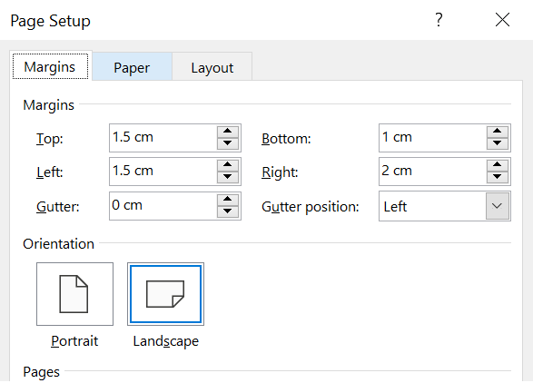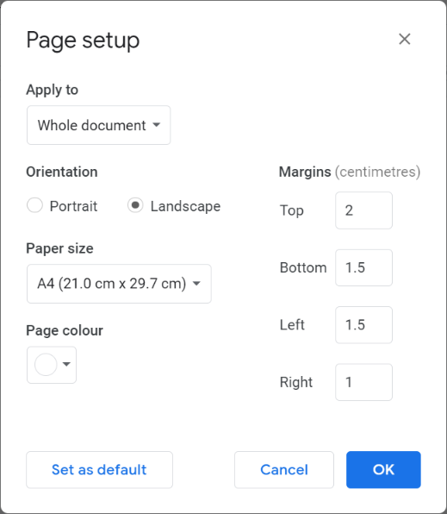

Microsoft Word
Google Docs

- Now you need to proofread the document and correct all the incorectly spelled words.

The line spacing and indentation of this paragraph do not match the rest of the text in this document. Change this paragraph so that it matches the layout of the text above. When you have done that, insert a table below this paragraph that has 2 collumns and 3 rows. Format the table so the left hand column is shaded light blue and the righrt hand column is shaded green.
From this point onwards, the text should be on page two of the document, so insert a page break here.

- Apply appropriate formatting to the phrases below and then make them a bullet point list. For example, the first phrase, Bold text, should be formatted as Bold text.
Bold text
Font size 34 pt
Font size 8 pt
Red text
Capital letters
Underlined text
Forte font
Italic text

5 Delete the following table and replace it with a picture of an Afghan hound.

- Format the ‘2’ in H2O so that it is _{subscript} and format ‘th’ in May 5th so that it is ^{superscript}.

- Finally, change the font of the message below to Times New Roman, size 27pt.
Well done you have the skills!

